Mobile Application Final Individual Project

Mark Zoiku

Ashesi University

Application Prototype

Welcome Page

On opening the application, the user can sign up if they have no account. If the user has an account they can select the sign in and enter user details. Other third party services like google is available if the user wants to sign in with them.

Figure 1: Create Account

Figure 2: Sign In

Dashboard

Upon creating account or logging in, user is directed to the user dashboard. On the dashboard, the user is able to view latest job vacancies, along with their listed jobs. With tabs to navigate the app, the user is able to view the Home, Jobs Listings, MyJobs, Profile, and the Sign Out.

Figure 3: Dashboard

Listings Tab

The listings tab, directs the user to a catalog of job categories from which they can preview available jobs. By selecting a particular category, the user is directed to a page with a list of available jobs in that category. The page containing the categories can be seen in Figure 4, while the page containing the categorized jobs can be viewed in Figure 5

Figure 4: Job Listing Categories

Figure 5: Categorized Job Listings

Post Job

On the listings page, the user can be able to locate and use the create job icon (pencil icon). By clicking that icon, the user is directed to a page to enter certain information about the job they want to post.

Figure 6: Post Job

My Jobs

After submitting/posting a job the user is directed to the MyJobs page to view a list of their uploaded job vacancy. The user can also navigate to this page via the MyJobs icon on the horizontal tab.

Figure 7: My Jobs

User Profile

The user is also able to view their Profile for information about their account.

Figure 8: User Profile

Entity Relation for Database

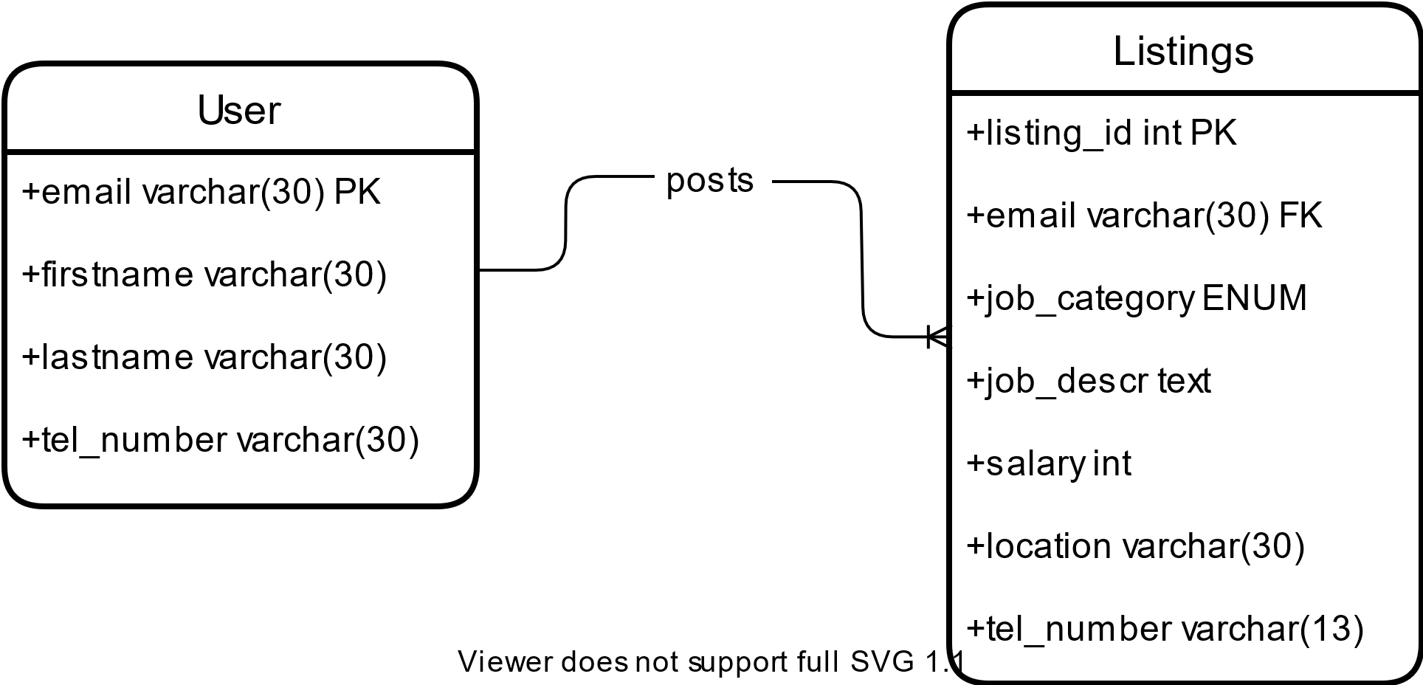

User

Registered Users are stored in the Users table

Listings

One user can post many job vacancy/ job listing.